How to Teach a New Game Name: _______________ Period: ___

My Game: _________________________________

Your task is to teach a game to your gaming group. Here’s what you need to do:

1. Learn the game.
   1. Read ALL of the rules.
      1. (optional) Go to [www.boardgamegeek.com](http://www.boardgamegeek.com) and look up the game. Watch tutorial videos if you like. Let Ms. Mercury know if there’s a rules or reference document you would like to have printed.
   2. Setup and play the game by yourself if possible..
2. Prepare to teach the game.
   1. Complete the How To Teach A Game Notes document to serve as a quick reference.
3. As you play games, fill out the Game Log as you play all games, including for your game.
4. After playing all games, fill out the Game Reflection and turn this packet in.

**As a player/learner:**

1. **Do not talk or interrupt the student teaching the game.** Save your questions for the end because the instructor will probably cover what you want to know.
2. During game play, do not talk to the person whose turn it is unless they ask for help or clarification. Keep all non-game chatter to a minimum.
3. If it is your turn, state, “I’m done” when your turn is over so the next player knows to go.
4. Please be aware that analysis paralysis can really slow down a game. Use other players’ turns for thinking so that when your turn comes, you can act quickly.
5. Complete your gaming log, taking notes on what you think about the game, including your game.
6. Put yourself in the position of a fellow game designer, not just a player. Think about all elements of the game (theme, mechanic, victory condition, board design, bits, etc) and imagine how the designer may have made those choices. Is there anything you’d change?
7. What was the best, coolest idea that the game designer had?
8. What was the most fun?

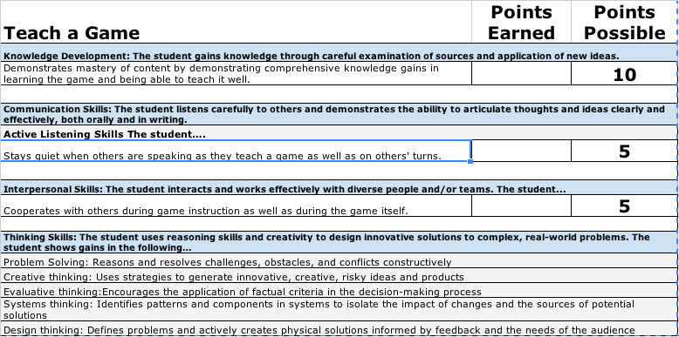

Total from Above--were you a good gamer and game teacher? ________ of 20

Prepared Notes Sheet ________ of 20

Completed Game Log ________ of 20

Game Reflection (summative!) ________ of 30

How to Teach a Game Notes Name: _______________ Period: ___

My game name: __________________________________

My game’s mechanics: ___________________________________________________________

Explain the game’s theme and story.

Explain the objective(s) for players.

Describe what happens on a turn. Discuss choices first, then go back and explain each one in depth. (Be prepared to explain sample turns using the pieces.)

Explain how the game ends and how a winner is determined.

**My Gameplay-Based Ideas Log** Name: _______________ Period: ___

For each game you play, (including your assigned game), write down at least three ideas you got from the game that you can apply to your own game. Use complete sentences. List the mechanics.

| **Game Name:** | **Mechanics** |
| --- | --- |
| Three ideas and how I will use them: |  |

| **Game Name:** | **Mechanics** |
| --- | --- |
| Three ideas and how I will use them: |  |

**My Gameplay-Based Ideas Log** Name: _______________ Period: ___

For each game you play, (including your assigned game), write down at least three ideas you got from the game that you can apply to your own game. Use complete sentences. List the mechanics.

| **Game Name:** | **Mechanics** |
| --- | --- |
| Three ideas and how I will use them: |  |

| **Game Name:** | **Mechanics** |
| --- | --- |
| Three ideas and how I will use them: |  |

How to Teach a Game Reflection Name: _______________ Period: ___

My name: _____________________________ My game name: _____________________

Other games that I played: __________________________________________________________

Answer the following questions thoughtfully with supportive evidence. Be VERY specific.

| Which game(s) did you like best, and why? Be specific using lush details about the theme, mechanics, or overall gameplay. Describe at least three different aspects of the same or different games. |
| --- |
|  |

| Describe three mechanics that you experienced in the different games and explain if you liked them, or not. |
| --- |
| 1.____________________________________________  2.____________________________________________  3.____________________________________________ |

| What choices did the game designers make that you think are interesting? Think about all game elements: theme, mechanic, victory condition, board design, bits, etc. Explain three choices. |
| --- |
|  |

| What changes would you make to a game to improve it, change it, or just for superfun good times yeah yeah?  Write the name of the game in the box, and explain how you would change it. |
| --- |
| | Theme |  | | --- | --- | | Mechanics |  | | Objectives/ Victory Conditions |  | |